Dis-ME- Syro-Hittite Bird Beaked Terracotta Statuette

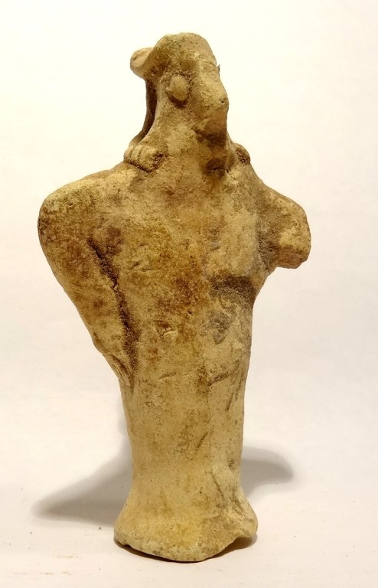 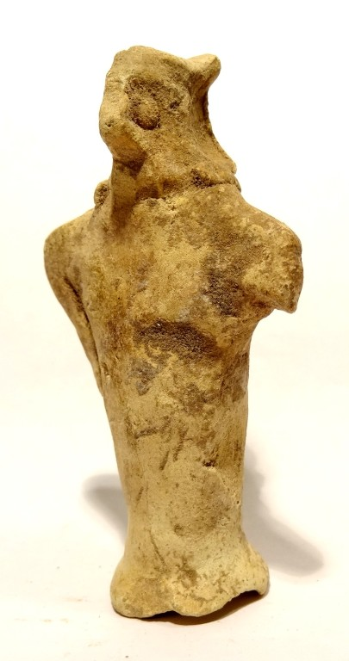 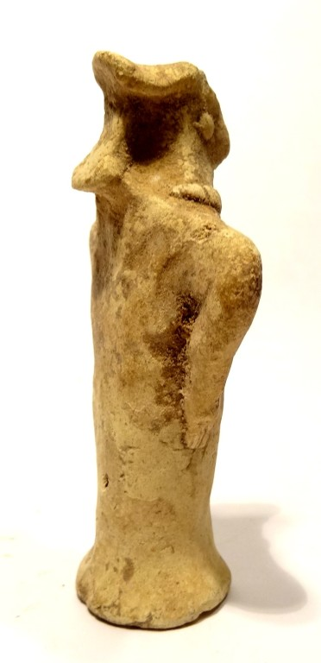 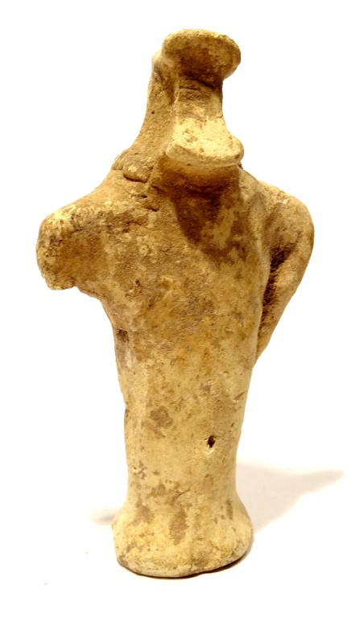 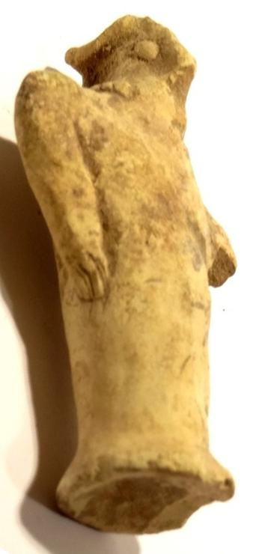

This bird-beaked terracotta is called a "pillar" statuette because of its pillar-like base. It has a bird beak, with arms akimbo positioned like wings along the body. The eyes are oversized (perhaps to denote a raptor’s exceptional vision) which are represented by two pellets. There is a strong prominence behind the head.

Among the Syro Hittite people the vulture was the bird that was invited to excarnate the body of the deceased and in the process would assume the wisdom of te deceased. This fgurines may be a model of the reinactment by a vulture priest of this event.  
Beige terracotta. Intact. Euphrates Valley, Syria - Anatolia, 2800-2600 BC

Formal Label: Syro-Hittite Bird Beaked Terracotta Statuette

Accession Number: NB130.A1

Date or Time Horizon: 2800-2600 BCE

Geographical Area: Syria-Anatolia

Cultural Affiliation: Syro-Hittite

Medium: Terracotta

Dimensions: H 78 mm

Weight:

**Condition**: One arm is missing, else very good. Hard and attractive patina, with calcareous adhesions.

Sold by [ancient_artonlin...](http://myworld.ebay.com/ancient_artonline) ( [1879](http://feedback.ebay.com/ws/eBayISAPI.dll?ViewFeedback&userid=ancient_artonline) )

Estimated delivery Tuesday, Dec 13, 2016 - Friday, Dec 23, 2016

#### [RARE STATUETTE IDOLE - VALLEE EUPHRATE- SYRO HITTITE 2600 BC - NEAR EASTERN IDOL](http://www.ebay.com/itm/201717385940)

|  |  |
| --- | --- |
| Item price | $175.90 |
| Quantity | 1 |
| Item number | 201717385940 |
| Shipping service | La Poste - Courrier International Prioritaire |